Katie Kouril
Module 4.2 Assignment
January 18, 2026
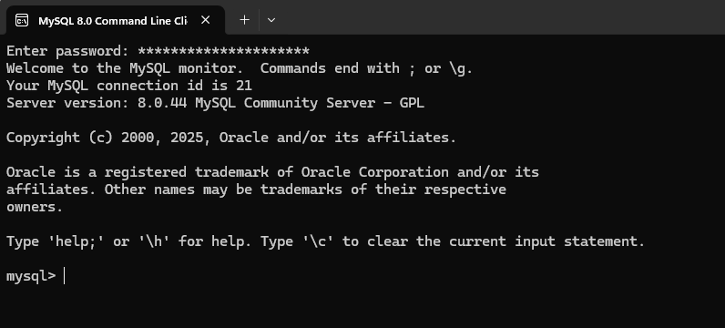

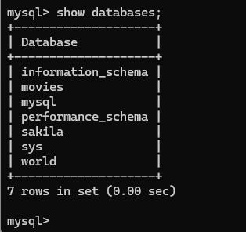

SELECT Statement
The SELECT statement is a fundamental part of SQL used to retrieve data that is stored in a table. By specifying the columns and the table, the SELECT statement allows you to extract the information you need from your database.
If using the select statement to pull the CustomerName from the movies database, one might use the alias ‘customer’.
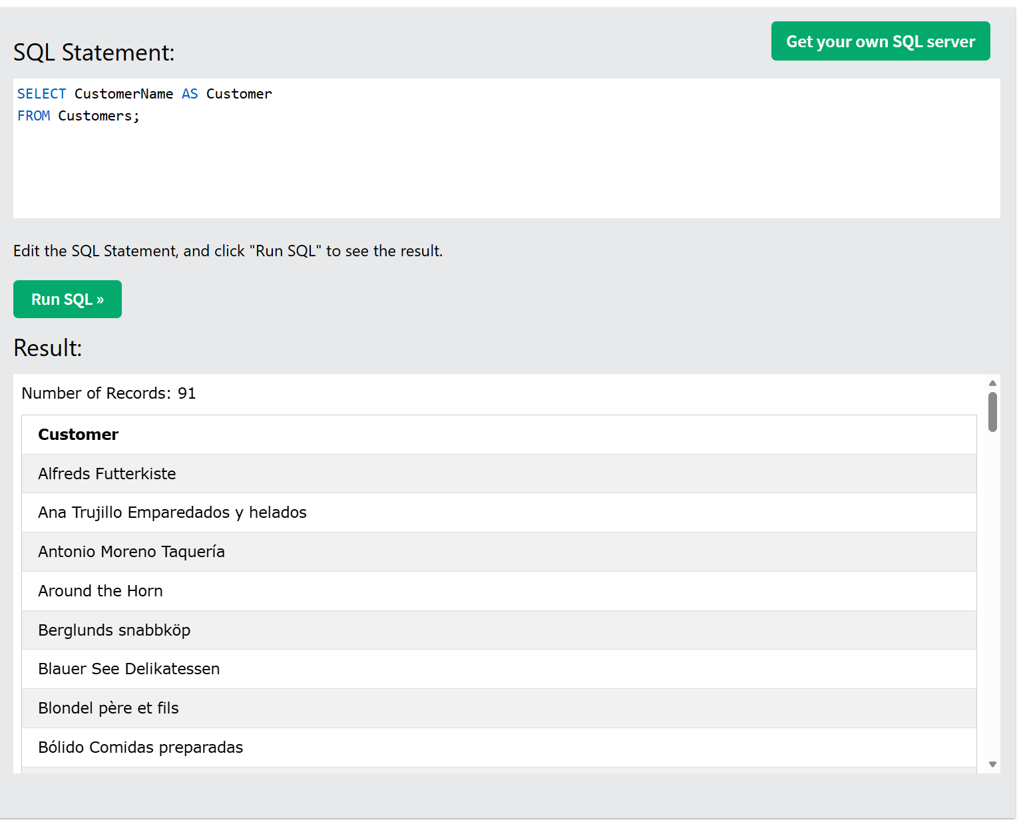

WHERE Clause
The WHERE clause is used to filter records and extract only those that meet certain conditions from the selected table. By applying specific criteria in the WHERE clause, you can narrow down the results to include only the relevant records.
If using the where clause to filter OrderIDs that were started by Employee 5, one might use the alias ‘Employee 5 Orders’.
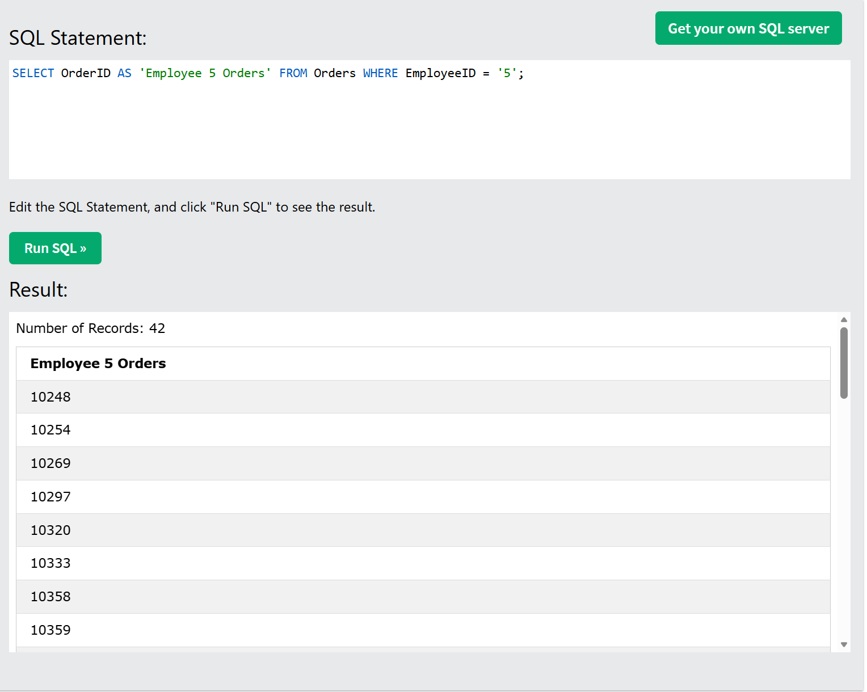

LIKE Operator
The LIKE operator is used in conjunction with the WHERE clause to search for a specified pattern within a column. It supports the percent '%' sign, which can represent zero, one, or multiple characters, and the underscore '_' character, which stands for a single character. This pattern-matching capability makes it easier to find records that meet specific search criteria.
If using the like clause to find OrderIDs belonging to the 10000-11000 range, one might use the alias ‘10000 Series Orders’.
